NATIONAL UNIVERSITY OF MODERN LANGUAGE ISLAMABAD
OEL


Submitted to:
Ms. Saadia Shabbir
Submitted by:
Zulqarnain Hassan
Roll No: …………………… SP21379
Subject: …………………… Web engineering
Department: ……………… BSSE-5-Afternoon
Date: ……………………… 25-12-2024

Lab Report: Pizza Ordering Web Application

1. Introduction
The objective of this lab was to create a functional pizza ordering web application using HTML, CSS, JavaScript, and PHP. This application simulates a real-world pizza-ordering scenario, allowing users to select pizzas, add extra toppings, calculate prices dynamically, apply discounts, and generate an order receipt.

2. Implementation Details

2.1 HTML (pizza-order.html)
The HTML file is the backbone of the application, containing the structure and layout of the web page. Key elements included:
- Header Section: Displaying the application title and navigation (if applicable).
- Pizza Selection: A section with buttons or an auto-slide feature to showcase available pizzas. Hover effects were added to display brief descriptions.
- Order Form: Inputs for selecting pizzas, extra toppings, delivery options, and entering a discount code.
- Submit Button: A button to place the order and trigger the server-side processing.

2.2 CSS (pizza-order.css)
The CSS file was used to style the application, focusing on:
- Layout Design: Arranging elements in a user-friendly and visually appealing manner.
- Hover Effects: Implementing tooltips over pizza names to display descriptions.
- Dynamic Styling: Adding a glowing effect to the price calculation box whenever the total price updates.
- Responsive Design: Ensuring the web page is accessible on various devices.

2.3 JavaScript (pizza-order.js)
JavaScript added interactivity and dynamic features:
- Pizza Selection and Price Calculation: Event listeners detect selections and update the total price in real time.
- Topping Selection: Prices increase or decrease based on user choices.
- Delivery Options: Adding $5 for home delivery or no charge for pick-up.
- Discount Code: Validating a discount code (e.g., DISCOUNT10) to apply a 10% discount or display an error message for invalid codes.
- Error Handling: Displaying warnings if no pizzas are selected when attempting to place an order.

2.4 PHP (pizza-order-processing.php)
The PHP file handled server-side processing:
- Form Validation: Checking that all required fields were completed and inputs were valid.
- Order Processing: Generating an HTML receipt summarizing the order, including:
  - Selected pizzas and toppings.
  - Delivery method.
  - Applied discounts.
  - Final price breakdown.
- Error Handling: Returning appropriate messages for invalid inputs or failed processing.

3. Challenges and Solutions
- Real-Time Updates: Ensuring price calculations reflected all user selections dynamically required precise event handling.
  - Solution: Implemented JavaScript event listeners and DOM manipulation techniques effectively.
- Discount Validation: Preventing invalid discount codes from affecting the total price.
  - Solution: Added client-side and server-side validation.
- PHP Integration: Handling form data securely and generating dynamic responses.
  - Solution: Used PHP functions like filter_input and htmlspecialchars to sanitize inputs.

4. Results
The following features were successfully implemented:
- A visually appealing interface for pizza selection.
- Real-time price updates with glowing effects.
- Functional discount code validation.
- Clear error messages and warnings.
- A dynamic, server-generated order receipt.

Screenshots:
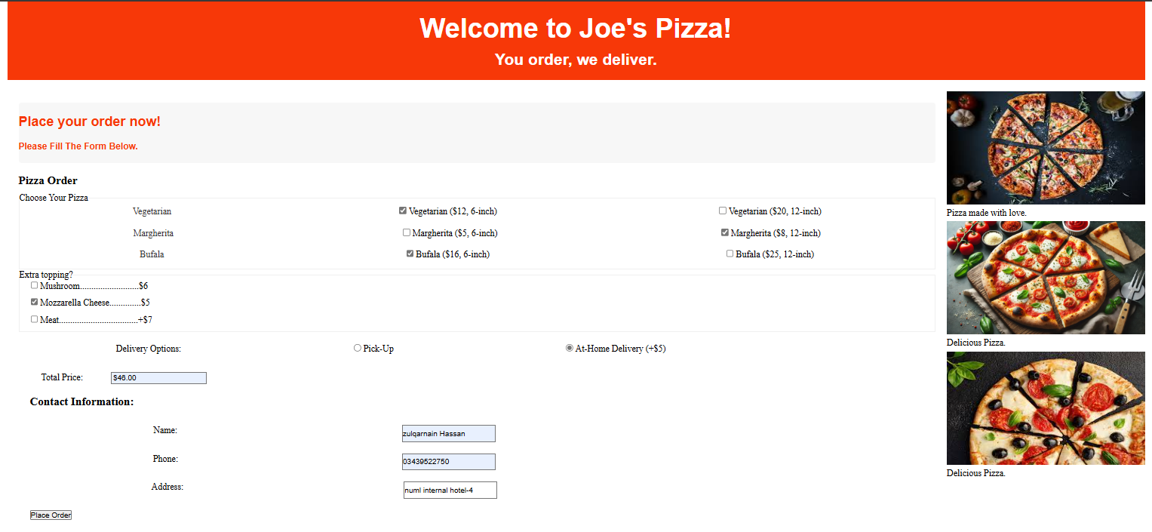


5. Conclusion
This lab provided practical experience in developing a fully functional web application, integrating front-end and back-end technologies. It enhanced skills in HTML, CSS, JavaScript, and PHP, offering insights into real-world web development scenarios.

